# Patch Arduino IDE

## Install ESP8266 programming environment

To be able to use the ESP8266 chip in the Arduino environment you need to install the ESP8266 environment into your IDE.

Please got to the preferences of your arduino IDE and add “http://arduino.esp8266.com/staging/package_esp8266com_index.json” into the field “additional Board Managers”. Separate entries with ; if you have more than one.

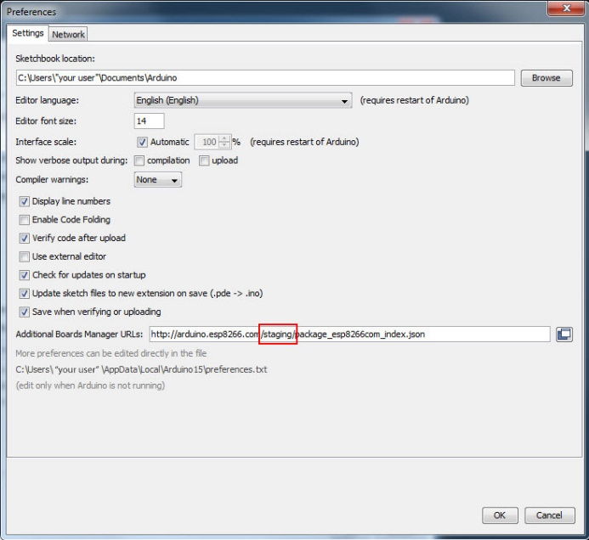

Then, you can go to File > Preferences > Boards Manager and search for “ESP8266”. Now, you can install version 2.3.0-rc2.

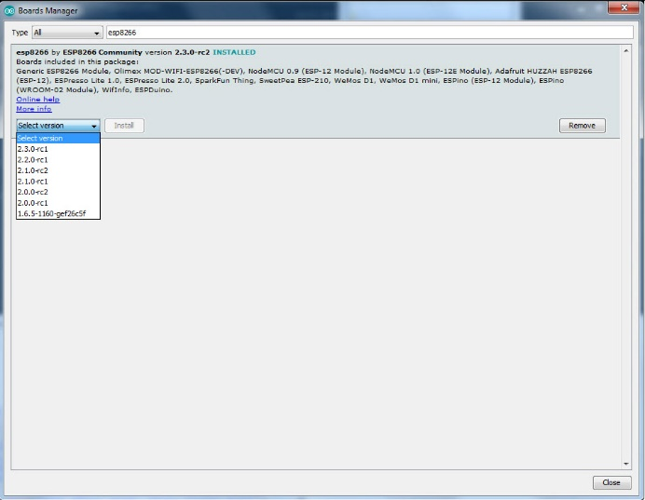

Now, you can program ESP8266 chips with your Ardiono IDE. Next, we have to patch two files to enable IOTappStory.com support. These patches add MD5 hash code checking to the environment. It is a pre-release of version 2.4.

## Patching the ESP8266 Core

Go to folder:

**Linux**: ~/.arduino15/packages/esp8266/hardware/esp8266/

**Mac**: ~/.arduino15/packages/esp8266/hardware/esp8266/

**Windows**: C:\Users\”your user”\AppData\Local\Arduino15\esp8266\hardware\esp8266\

-or-

C:\Users\”your user”\AppData\Local\Arduino15\packages\esp8266\hardware\esp8266\

If you do not find this folder, enable verbose for compilation in your preferences:

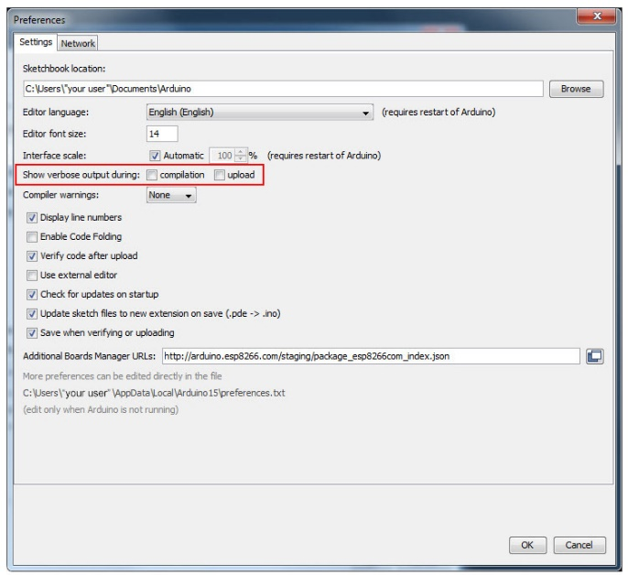

Load the “blink” example, and compile it. During this process, you find the directory used by your computer:

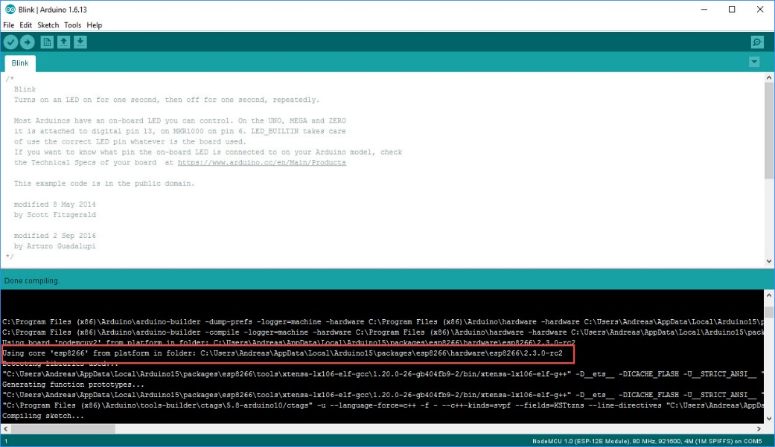

Use this one.

Now, you should see this directory:

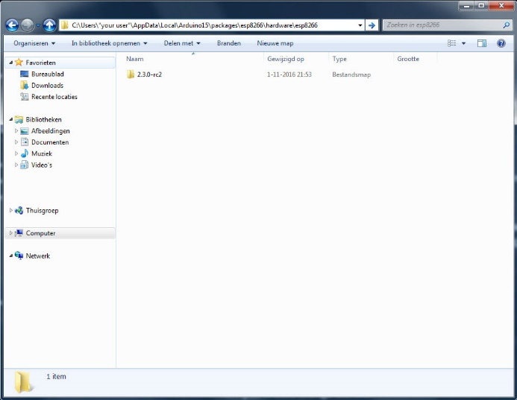

Check, if you only have the 2.3.0-rc2 folder. Delete any other folders.

Please download the zip file from <https://github.com/SensorsIot/IOTAppstory.com> and copy the directory 2.3.0-rc2 into this directory.

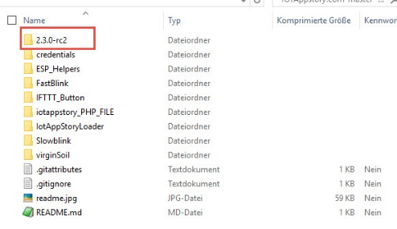

It will replace esp.h and esp.cpp with the files from Github

Restart you Arduino IDE and you should be ready to go.